IIITD&M Kancheepuram

**Problem solving and programming**

**Date: 24 JAN 2021**

**Duration: 01 Hr. Total Marks: 20**

1. What is the output for the following program? Justify your answer properly

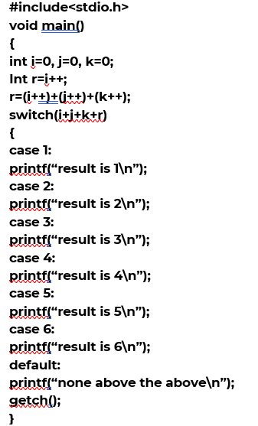

1. Find the output of the below program and justify your answer?

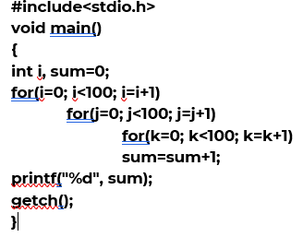

1. **What does the following code do ? Explain with x=7, y=19. Hand simulate all steps and arrive at a conclusion.**

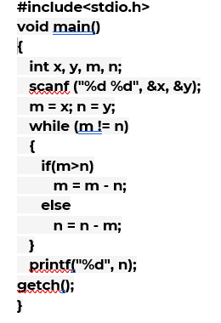

1. (73) base X = (54) base Y. Find the possible values for X and Y.
2. Represent the decimal number -15 in a 2’s complement form?
3. Give the 8-bit signed magnitude representation of following decimal numbers. Include steps followed for each conversion. (2 marks)

A) -9 , B) 50 , C) -100 D) 27

7. Perform binary subtraction using 2’s complement for the following. Check that it is correct by including the decimal equivalents. Include steps followed for each conversion. (2m)

* 1. 1011011 − 10010
  2. 1110110 − 1010111

1. What is the difference between i++ & ++i. Illustrate using an example. And calculate the value of variable ‘x’ for the code given below.

int x=10;

x = (x++) + (++x) +x;

x+=11;

**9.** What do you mean by left shift and right shift. How will you perform left shifting in C-programming. Perform the following ( mention all the steps, do not directly write the answer)

(a)Left shift integer 45 by 3 places.

(b)Right shift integer 44 by 3 places.

1. Write a program to check if a number is odd or even using Ternary